BOC API Document Debugging Process
Debugging Process for “Customer”
Pass the terminal in “Back End”, and refresh the http://localhost:4200/#/admin/repair-request/add page in chrome.

Open the “Back End” codebase, set the “breakpoint” in line 119 and click “Run and Debug” button,
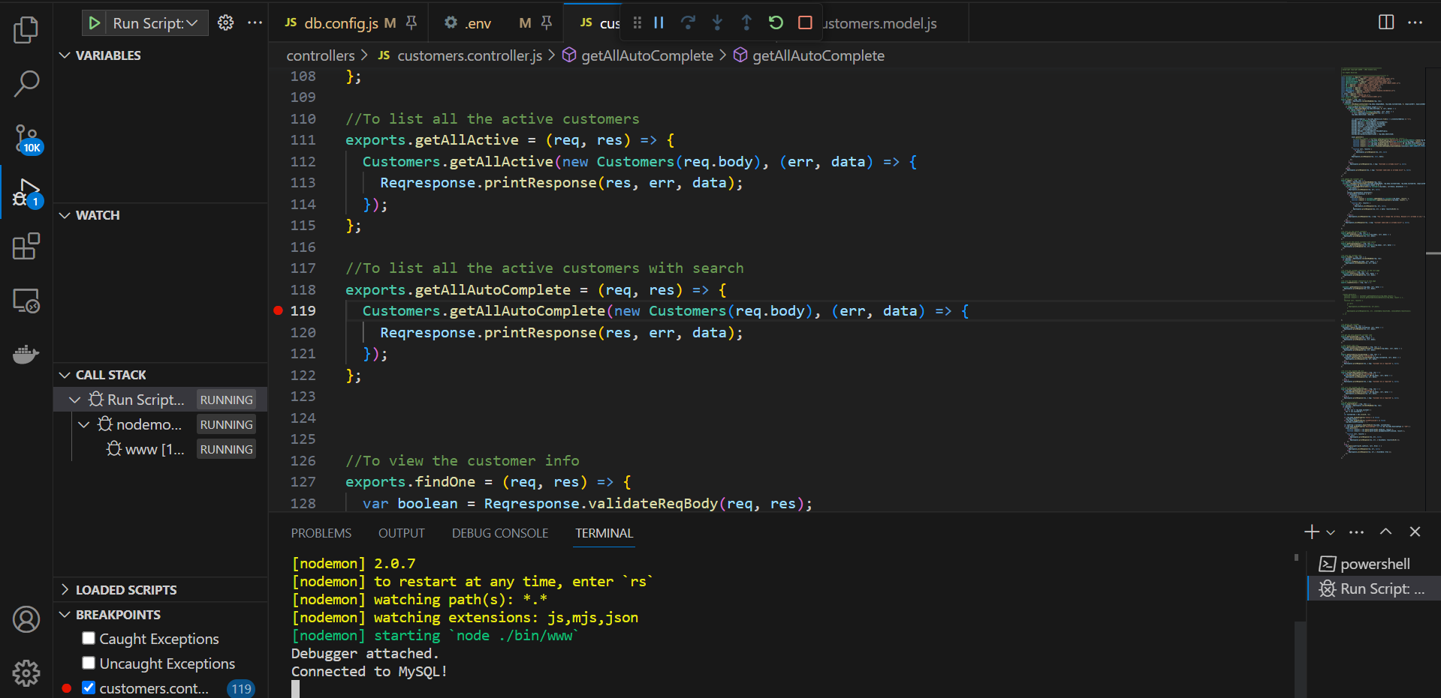

Type “BOC” in “Customer” field,
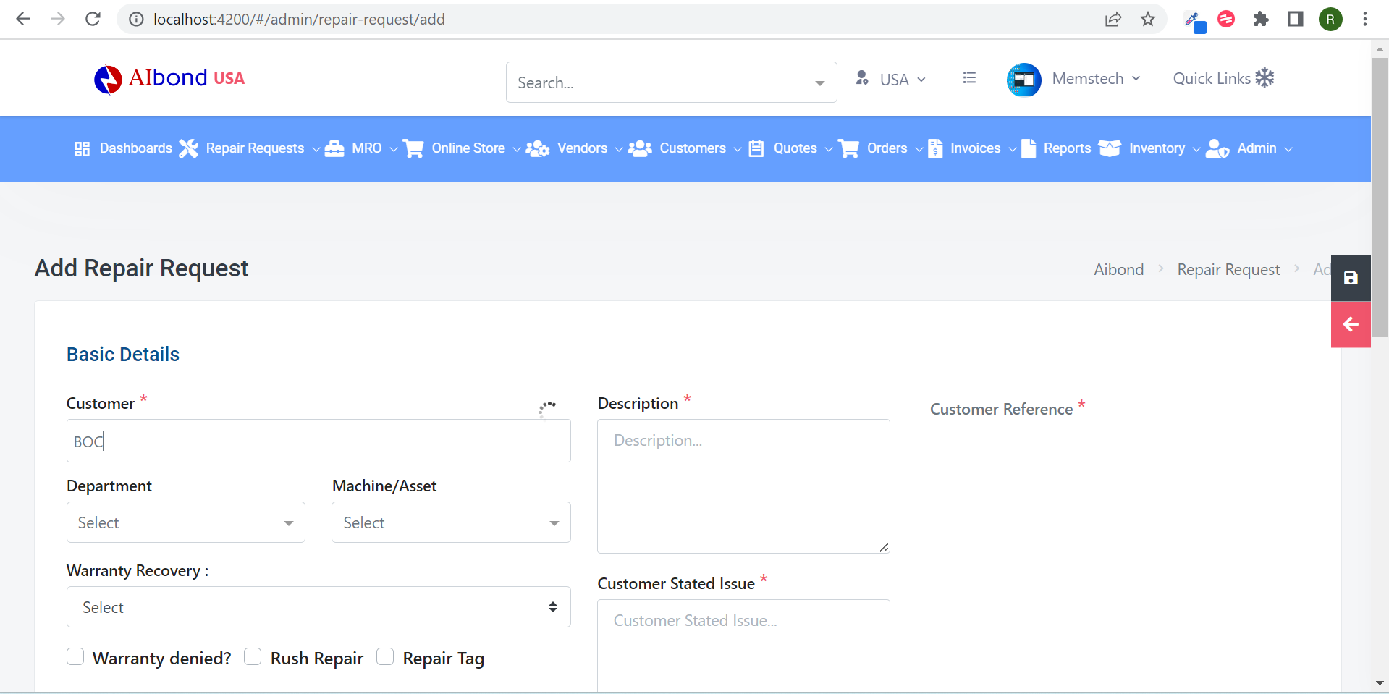
Open “Back End” codebase,
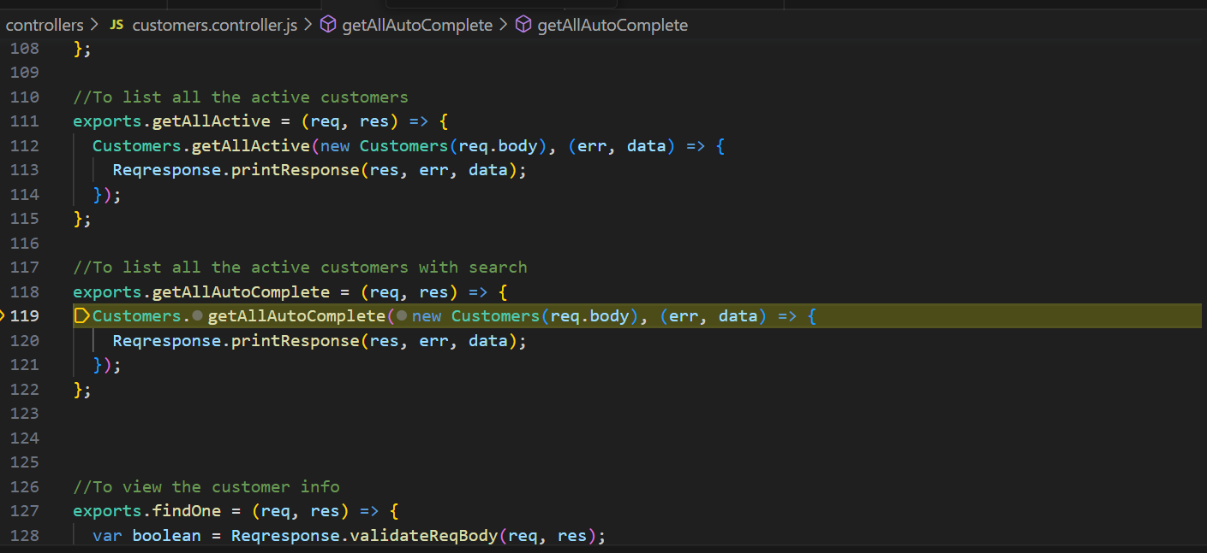“Breakpoint” will be started in “customer.controller.js” file. If you hover on each terms, it will show its descriptions.
Click “Step Into (F11)” button, it will shows its complete steps one by one in “customers.model.js” file,
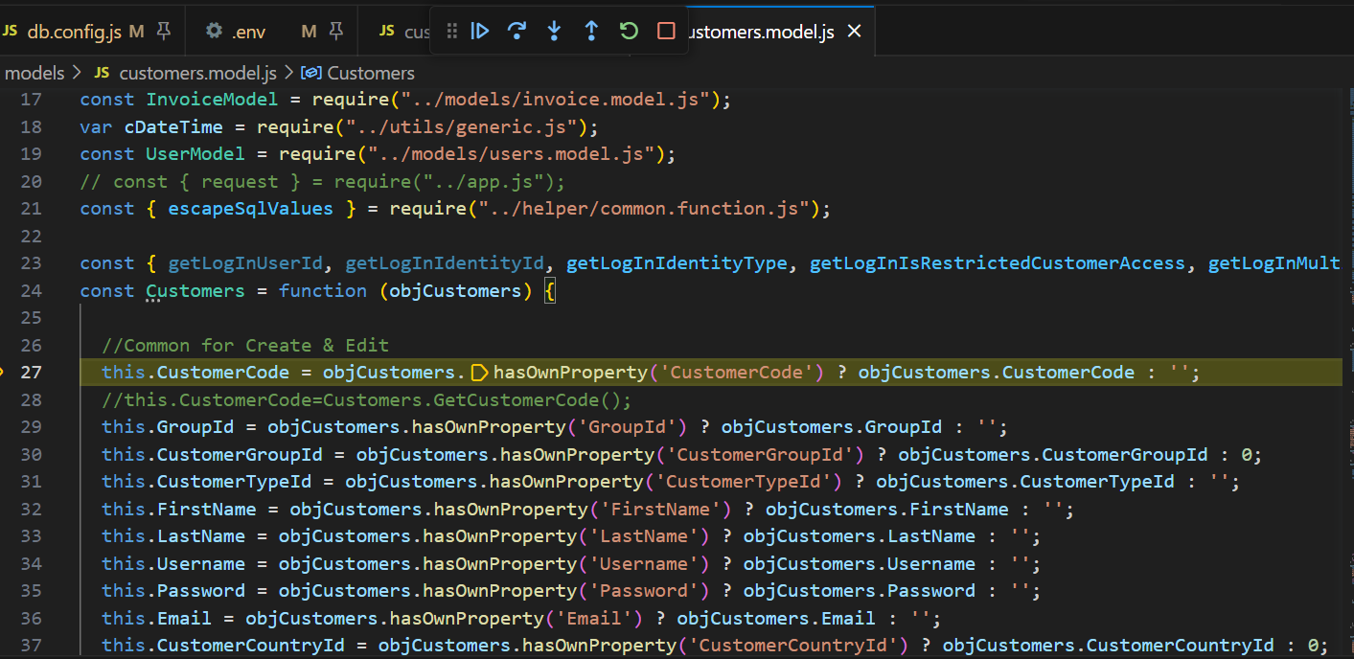
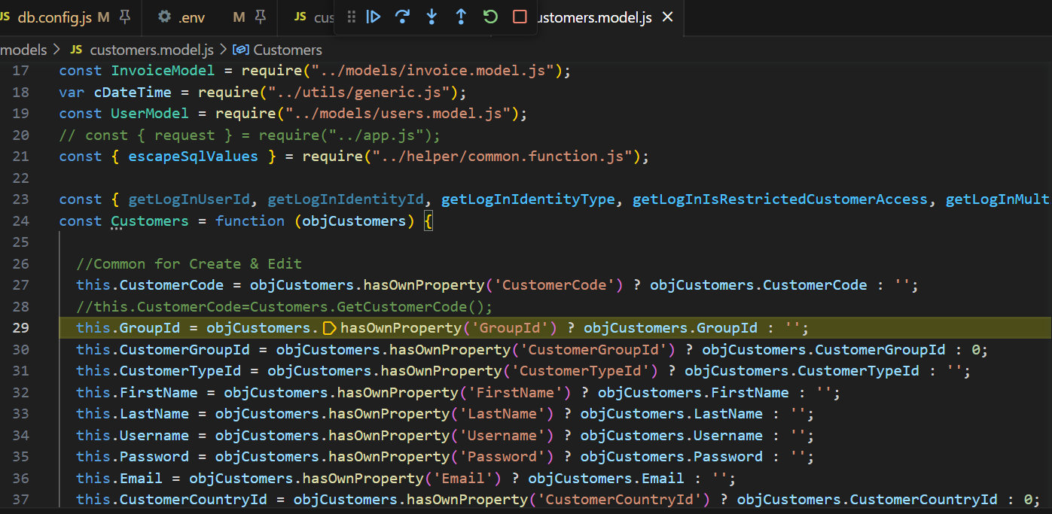
And goes on.
Click “Step Out (Shift+F11)” button to go its initial step i.e., to “customer.controller.js” file.

